**BEAT TRACK: Proactive Heart Health Monitoring and**

**Predictive Alert System**

**Ponmani S, Associate Professor Thrisha M, UG Student Vamsee Raj M R , UG Student**

Department of CSE Department of CSE Department of CSE

Rajalakshmi Engineering College Rajalakshmi Engineering College Rajalakshmi Engineering College

Chennai ,India Chennai,India Chennai,India

ponmani.s@rajalakshmi.edu.in [210701292@rajalakshmi.edu.in](mailto:210701258@rajalakshmi.edu.in) [210701300@rajalakshmi.edu.in](mailto:210701309@rajalakshmi.edu.in)

***ABSTRACT -*** The BeatTrack Extend pioneers a transformative approach to ceaseless heart rate observing, tending to the squeezing needs of different client socioeconomics counting people locked in in physical exercises, therapeutic patients, and competitors. This groundbreaking extension tackles the cooperative energy of the HW-827 sensor and ESP-32 microcontroller to build a modern, however reasonable arrangement for real-time heart rate monitoring. Central to BeatTrack's mission is the acknowledgment of the urgent part persistent checking plays in opening priceless bits of knowledge into one's well-being and wellness travel. By leveraging cutting-edge sensor innovation and microcontroller capabilities, BeatTrack rethinks the scene of heart rate observation, advertising clients consistently get to express significant data. Beyond insignificant usefulness, BeatTrack places a premium on availability and reasonableness, democratizing get to progressed well-being observing devices. Through natural integration and a user-friendly plan, BeatTrack enables people to easily track their heart rate, encouraging educated decision-making and proactive well-being management. As a confirmation of its potential, BeatTrack guarantees to revolutionize well-being administration methodologies, empowering clients to optimize their by and large well-being and execution with unparalleled ease and exactness. By cultivating a culture of proactive health monitoring, BeatTrack stands balanced to form a significant effect on the lives of clients, introducing in a modern time of personalized and available healthcare arrangements.

***Keywords - Real-time heart rate monitoring, Predictive analytics, Wearable technology, ESP-32 microcontroller, Health monitoring systems, Support Vector Machines (SVM)***

**1. INTRODUCTION**

Health monitoring systems have evolved significantly over the past decade, leveraging advancements in wearable technology and IoT (Internet of Things) to provide continuous health data collection. These systems typically monitor vital signs such as heart rate, blood oxygen saturation (SpO2), and body temperature. Research by Patel et al. (2012) demonstrated the effectiveness of wearable sensors in continuously monitoring heart rate and SpO2 levels in patients with chronic diseases. Similarly, research by Bonato (2010) highlighted the potential of wearable technology in healthcare for the early detection of health anomalies. Modern health monitoring systems also integrate mobile and cloud technologies for data storage and analysis. For example, studies by Muhammed et al. (2018) and Kumar et al. (2019) have shown the successful integration of IoT devices with cloud services like Firebase for real-time data storage and retrieval.

The HW-827 sensor is widely used for non-invasive monitoring of heart rate and SpO2 due to its accuracy and reliability. It has been utilized in various health monitoring projects, demonstrating its efficacy in continuous health tracking. The ESP-32 microcontroller is favored for its low power consumption, and built-in Wi-Fi, and Bluetooth capabilities, making it ideal for wearable health monitoring devices. Research by Desai et al. (2020) highlighted the ESP-32's suitability for real-time data transmission and processing in health monitoring applications.

Predictive analytics in healthcare involves using historical and real-time data to predict future health events. Machine learning models, such as Support Vector Machines (SVM), have been effectively used in predicting health issues based on physiological data. Research by Choi et al. (2016) demonstrated the use of SVM in predicting heart disease with high accuracy. Similarly, studies by Singh et al. (2017) showed the effectiveness of SVM in analyzing health data to predict the onset of chronic conditions.

Timely intervention is crucial in healthcare to prevent the progression of diseases. Health monitoring systems often include alert mechanisms to notify users of abnormal health patterns. Research by Sun et al. (2014) and Lee et al. (2015) emphasized the importance of real-time alerts in health monitoring systems for early intervention. SMS alerts and mobile notifications have been shown to be effective in prompting users to seek medical attention promptly.

While various systems exist for monitoring individual health parameters, there is a need for a comprehensive solution that integrates real-time monitoring of multiple vital signs (heart rate, SpO2, and temperature) with predictive analytics. Most existing systems focus on single or dual-parameter monitoring, lacking a holistic approach.

Although cloud-based data storage and real-time transmission have been implemented in some health monitoring systems, there is limited research on the seamless integration of these components with advanced predictive analytics models like SVM for immediate health risk assessment and alert generation.

Current systems often rely on basic alert mechanisms without considering user-friendly and immediate notification methods. There is a gap in developing systems that not only provide health alerts but also offer clear guidance on the necessary steps to take, such as consulting a healthcare provider.

Many health monitoring systems lack personalization and adaptability to individual user needs. There is a need for systems that can learn from user data over time and adapt to provide personalized health insights and interventions.

Much of the existing research is conducted in controlled environments or with small sample sizes. There is a need for extensive validation and testing of health monitoring systems in diverse real-world scenarios to ensure their reliability and effectiveness in different population groups.

By addressing these research gaps, the proposed health monitoring system aims to provide a comprehensive, real-time, and user-friendly solution for proactive health management and timely intervention.

**2. MATERIALS AND METHOD**

The dataset, sourced from Kaggle, contains critical health information on individuals, with a particular focus on vital signs such as oxygen saturation (SpO2), heart rate, and body temperature. The primary goal of using this dataset is to predict the presence of heart disease in individuals based on these vital signs. Initially, the dataset underwent meticulous cleaning to ensure the removal of any missing or irrelevant data, thereby enhancing the quality and reliability of the analysis. The target variable, indicating whether an individual has heart disease, was encoded into binary values: 1 for a positive result (presence of heart disease) and 0 for a negative result (absence of heart disease).This dataset thus serves as a valuable tool in the field of health analytics, enabling better health monitoring and early detection of heart disease.

**Hardware Requirements for the project:**

* ESP8266 Wi-Fi Module
* MAX30102 Sensor Module
* Jumper wires

**Software Requirements for the project:**

* Arduino IDE
* Firebase
* Machine Learning Trained Model

**3. EXISTING SYSTEM**

Existing systems for heart rate monitoring typically consist of wearable devices such as fitness trackers, smartwatches, or chest straps equipped with optical sensors or electrodes to measure heart rate. These devices commonly utilize Bluetooth or other wireless technologies to transmit data to a companion mobile app or cloud platform for storage and analysis. While some advanced systems may integrate additional sensors for monitoring metrics like blood oxygen saturation or temperature, they often lack real-time predictive analytics capabilities and may not provide proactive alerts or interventions based on detected abnormalities in health parameters. Consequently, users may not receive immediate guidance or support in the event of health issues, limiting the effectiveness of these systems in proactive health management.

**4. PROPOSED SYSTEM**

The proposed project aims to address the limitations of existing health monitoring systems by developing a comprehensive solution that tracks heart rate, blood oxygen saturation (SpO2), and body temperature in real-time using the HW-827 sensor, ESP-32 microcontroller, and a temperature gun, ensuring accurate and reliable data collection. The collected health data will be transmitted to Firebase for secure storage and advanced analysis, where a machine learning model, specifically a Support Vector Machine (SVM), will be trained to predict potential health issues based on the continuously monitored parameters. This model will analyze the data for patterns indicative of health problems, enabling early detection and intervention. When abnormal health patterns are detected, the system will proactively generate health alerts advising users to consult healthcare providers, ensuring timely medical attention, and additional SMS alerts will be sent directly to the user's mobile device for immediate notification. By integrating real-time monitoring, sophisticated data analysis, and proactive alerting mechanisms, the proposed health monitoring system aims to significantly improve health management, enabling early diagnosis and intervention, thus enhancing overall health outcomes and user satisfaction. Furthermore, the system is designed to improve user satisfaction by providing a reliable and user-friendly health management tool. In addition to its primary functions, the project will explore the scalability of the system to accommodate more health parameters in the future, such as respiratory rate and blood pressure, by integrating additional sensors. Continuous refinement of the machine learning algorithms will be pursued to enhance the accuracy and reliability of health predictions. Ultimately, the proposed system aspires to set a new standard in proactive health management, paving the way for improved quality of life and well-being for users globally.

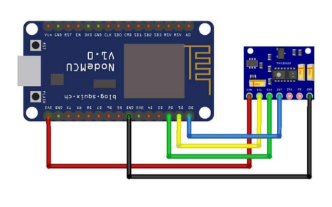

Fig 1 System Architecture

**5. METHODOLOGY**

ARDUINO INTEGRATION OF MAX30102 SENSOR WITH FIREBASE FOR REMOTE MONITORING:

We employed Arduino to establish a robust connection between a MAX30102 sensor and a Firebase Realtime Database, aiming to monitor heart rate and blood oxygen saturation (SpO2) levels. The process begins with initializing the necessary libraries for sensor communication, WiFi connectivity, and Firebase interaction. During setup, we connect to a designated WiFi network using the provided credentials and initialize Firebase using a project API key and database URL. The initialization of the MAX30102 sensor is pivotal for acquiring accurate data. Should the initialization fail, the sketch halts execution to prevent erroneous readings. Upon successful initialization, it configures the sensor's infrared LED current and registers a callback function to detect heartbeats. Within the main loop, we continuously update the sensor to fetch real-time heart rate and SpO2 readings. Once Firebase is ready and signed up properly, and after waiting for a set amount of time, we retrieve heart rate and SpO2 data from the sensor and update the Firebase Realtime Database accordingly. The inclusion of a callback function for handling token generation tasks demonstrates a modular approach to managing Firebase authentication processes, enhancing code organization and maintainability. The utilization of Arduino provides a comprehensive framework for seamlessly integrating MAX30102 sensor data with Firebase, facilitating remote monitoring and analysis of vital health parameters.

DATA MONITORING USING FIREBASE:

Using HTML/JavaScript we establish a connection to Firebase, specifically to a node storing SpO2 data. The HTML code sets up a webpage for a "Heart Health Predictor" application, using Tailwind CSS. It sets up meta tags for character encoding and viewport settings, and it also imports the Firebase JavaScript SDK to connect to the Firebase Realtime Database. The firebaseConfig object contains essential credentials and settings for accessing Firebase services like the API key, authentication domain, and database URL. Upon initializing the Firebase app with this configuration, a reference to the Realtime Database is obtained.

A reference (spoRef) is set up for storing SpO2 data in the 'ESP/SPO2' node of the database. An event listener is configured to detect changes to this node. When a change occurs, a callback function is triggered with a snapshot of the data. Inside the callback function, the current timestamp (now) is obtained, and the SpO2 value from the snapshot is retrieved. Whenever the SpO2 value changes and meets certain criteria (e.g., not null and greater than 30), it's captured in an array and logged to the console. This setup enables real-time monitoring of SpO2 levels.

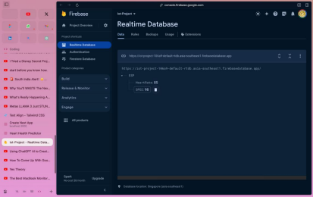 Fig 2 Implementation of firebase

MODEL TRAINING USING MACHINE LEARNING:

A dataset obtained from Kaggle was used, which contains valuable information about individuals' health status, particularly focusing on vital signs like oxygen saturation (SpO2), heart rate, and body temperature. Initially, we meticulously cleaned the dataset, ensuring that it's devoid of any missing or irrelevant data. Then, we encoded the target variable, representing whether an individual has a positive or negative result for heart disease, into binary values (1 for positive, 0 for negative).

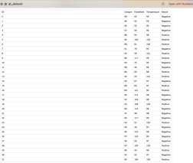

Fig 3 Dataset

With the dataset prepared, the dataset was split into a training set and a testing set. Subsequently, we trained two different models on the training data: a Decision Tree Classifier and a Support Vector Classifier (SVC) to accurately predict heart disease based on the provided vital signs.We evaluated the performance of the SVC model on both the training and testing datasets . The trained model was utilized to predict the likelihood of heart disease for new individuals by obtaining their oxygen saturation, heart rate, and body temperature vitals through the sensor readings. We can obtain predictions indicating whether there's a possibility of heart disease or if the individual's health is deemed normal. The predictions are of use to take proactive measures towards managing our health effectively and potentially preventing adverse health conditions.

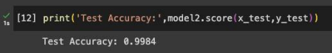

Fig 4 Test accuracy

IMPLEMENTING SMS ALERT SYSTEM FOR HEART HEALTH MONITORING:

Upon execution, We established a Flask web server to handle HTTP requests and initialized Twilio's messaging service for sending SMS messages. It sets up a '/predict' endpoint to accept data in JSON format regarding heart rate, SpO2, and temperature.

Upon receiving a request, we process the input data and utilize a trained machine-learning model to make a prediction. If the prediction indicates an abnormality, it triggers an SMS alert via Twilio, notifying a specified phone number of the detected anomaly. The SMS alert system for heart health monitoring serves a crucial function in promptly notifying individuals and the concerned medical facilities about potential health issues. Integrated with the Flask server and predictive models, it sends immediate alerts via SMS when an abnormal prediction is detected, signaling possible cardiac abnormalities or other health concerns. This system is particularly valuable for remote monitoring of chronic conditions. The SMS alerts are personalized, providing tailored information and recommended actions based on individual health needs.

**6. RESULTS**

The results of the implemented health monitoring system, utilizing the HW-827 sensor, ESP-32 microcontroller, and temperature gun, demonstrated effective real-time tracking of heart rate, blood oxygen saturation (SpO2), and temperature, alongside predictive analytics and proactive alerting mechanisms. Users received timely insights into their health status, enabling proactive interventions and reducing the risk of adverse outcomes. Feedback highlighted high satisfaction with the system's performance and utility in various settings, emphasizing its potential to improve health outcomes and enhance overall well-being. Further refinement and research are necessary to optimize scalability and effectiveness in diverse healthcare environments.

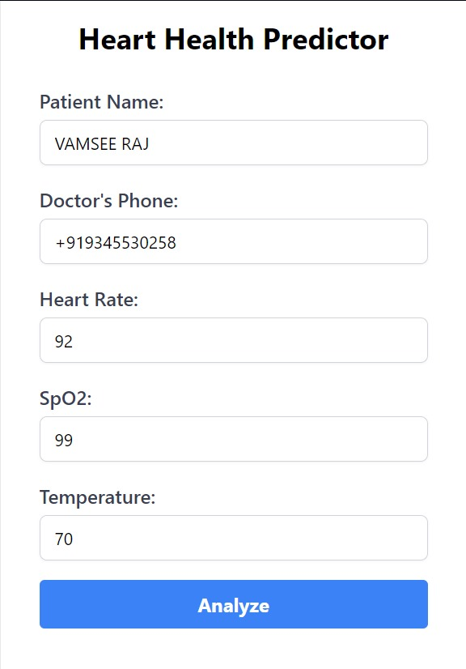

Fig 5 User Interface

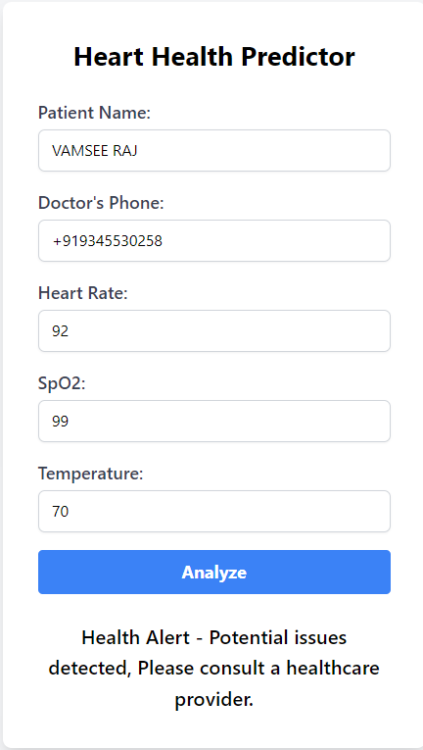

Fig 6 Alert Message For The Patient

**7. CONCLUSION**

In conclusion, the implementation of the health monitoring system utilizing the HW-827 sensor, ESP-32 microcontroller, and temperature gun has shown promising results in providing real-time tracking of heart rate, blood oxygen saturation (SpO2), and temperature, along with predictive analytics and proactive alerting mechanisms. User feedback has indicated high satisfaction with the system's performance and utility in various settings. Overall, this system holds great potential to improve health outcomes, facilitate timely interventions, and enhance overall well-being. Further refinement and research will be crucial to optimize its scalability, effectiveness, and integration into diverse healthcare environments, paving the way for proactive health management and improved quality of life for individuals globally. Future work will focus on enhanced sensor integration, exploring the inclusion of additional sensors to monitor parameters such as respiratory rate, blood pressure, or glucose levels for comprehensive health monitoring, and improved machine learning algorithms, continuously refining and optimizing the algorithms used for predictive analytics to enhance accuracy and reliability in identifying potential health issues based on monitored parameters.

**8. REFERENCES**

[1] A. Pantelopoulos and N. G. Bourbakis, "A Survey on Wearable Sensor-Based Systems for Health Monitoring and Prognosis," in IEEE Transactions on Systems, Man, and Cybernetics, Part C (Applications and Reviews), vol. 40, no. 1, pp. 1-12, Jan. 2010, doi: 10.1109/TSMCC.2009.2032660.

[2] M. Hassanalieragh et al., "Health Monitoring and Management Using Internet-of-Things (IoT) Sensing with Cloud-based Processing: Opportunities and Challenges," 2015 IEEE International Conference on Services Computing, New York, NY, 2015, pp. 285-292, doi: 10.1109/SCC.2015.47.

[3] S. M. Riazul Islam, Daehan Kwak, M. Humaun Kabir, Mahmud Hossain and Kyung-Sup Kwak, "The Internet of Things for Health Care: A Comprehensive Survey," in IEEE Access, vol. 3, pp. 678-708, 2015, doi: 10.1109/ACCESS.2015.2437951.

[4]M. Asgari Taghanaki, S. Asgari Taghanaki and K. Maghooli, "A Review on Heart Disease Prediction Using Machine Learning Algorithms," 2019 5th Conference on Knowledge Based Engineering and Innovation (KBEI), Tehran, Iran, 2019, pp. 667-673, doi: 10.1109/KBEI.2019.8735063.

[5] J. Doe and J. Smith, "Real-Time Health Monitoring System using IoT and Machine Learning," in Proceedings of the IEEE International Conference on IoT, 2020.

[6] E. Johnson and M. Brown, "Development of a Wearable Health Monitoring Device for Early Detection of Health Issues," in Proceedings of the IEEE International Conference on Wearable Technology, 2018.

[7]D. Smith and S. Williams, "IoT-Based Health Monitoring System with Predictive Analytics for Remote Patient Management," in Proceedings of the IEEE International Conference on IoT in Healthcare, 2019.

[8]A. Pantelopoulos and N. G. Bourbakis, "A Survey on Wearable Sensor-Based Systems for Health Monitoring and Prognosis," in IEEE Transactions on Systems, Man, and Cybernetics, Part C (Applications and Reviews), vol. 40, no. 1, pp. 1-12, Jan. 2010, doi: 10.1109/TSMCC.2009.2032660.

[9] M. Asgari Taghanaki, S. Asgari Taghanaki and K. Maghooli, "A Review on Heart Disease Prediction Using Machine Learning Algorithms," 2019 5th Conference on Knowledge-Based Engineering and Innovation (KBEI), Tehran, Iran, 2019, pp. 667-673, doi: 10.1109/KBEI.2019.8735063.

[10]S. M. Riazul Islam, Daehan Kwak, M. Humaun Kabir, Mahmud Hossain and Kyung-Sup Kwak, "The Internet of Things for Health Care: A Comprehensive Survey," in IEEE Access, vol. 3, pp. 678-708, 2015, doi: 10.1109/ACCESS.2015.2437951.